Object Oriented Analysis

Last Revision Date: 11/3/11

1. System Overview
2. Class Model
   1. Classes
   2. Class Diagram
3. Dynamic Model
   1. Scenarios
   2. State Diagrams
4. Functional Model
5. Revision History

1. System Overview

ConnActiv is a social network meant to connect people who participate in physical activities. Its goal is to allow users to meet other people in an area based on a mutual interest in sports, running, hiking, etc. Users will be able to subscribe to different activities based on their interest (e.g. a running “activity”). Each activity feeds into its own public stream containing posts that mention or "tag" the activity, as well as any other relevant updates. The stream is able to be seen in a user's “Home” view if he or she is subscribed to the particular activity. This public stream is intended for users to post what activity they are doing and when. This allows other users to join them if the original user allows invitations to his or her posts. Users will also be able to post to their private stream where only users he or she has connected with may see.

For example, Jon posts the following message on the site’s “Running” section: “Hey, going out for a run in Oakland at 9AM.” If Jon has allowed it, Stacy may ask to join Jon in running that day.

Finally, users may give other users recommendations after they have done an activity together. This gives other users an opportunity to see if the user in question would be a suitable activity partner; however, because this could potentially lead to cyber bullying in the form of malicious reviews users are limited to one review per activity with the person in question.

1. Class Model
   1. Classes

USER(user_id, firstName, lastName, street, city, zip, phone, interests, profile_pic)

NETWORK(networkId, area, activity)

CONNACTION(connactionId, location, startTime, endTime, activityId)

ACTIVITY(activityId, activityName)

REVIEW(userId. connactionId, thUp_thDn)

COMMENT(commentId, fromUser, toUser, comment, commentDate)

MESSAGE(fromUser, toUser, subject, body, date)

SUBSCRIPTION(subscriptionId, networkId, userId)

EVENT(eventId, startDate, endDate, activityId, location, recurrence)

PICTURE(pictureId, userId, path)

* 1. Class Diagram

Comment

Subscription

Message

User

Event

Review

UserId: Int

ConnactionId: Int

thUp_thDn: Boolean

Network

NetworkId: Int

Area: String

Activity: Int

Connaction

ConnactionId: Int

Location: String

StartTime: Date

EndTime: Date

ActivityId: Int

UserId: Int

FirstName: String

LastName: String

Street: String

City: String

State: char(2)

Zip: Int

CommentId: Int

FromUser: Int

ToUser: Int

Comment: String

CommentDate: Date

FromUser: Int

ToUser: Int

Subject: String

Body: String

Date: Date

SubscriptionId: Int

NetworkId: Int

UserId: Int

EventId: Int

StartDate: Date

EndDate: Date

ActivityId: Int

Location: String

Recurrence: String

ActivityId: Int

ActivityName: String

Activity

1. Dynamic Model
   1. Scenarios

Scenario 1 – Post an Activity

* User selects what Activity Stream to post to
* User selects what kind of Activity
* User can leave a small message
* User selects what time
* User specifies difficulty levels
* User’s Activity gets posted to selected stream

Scenario 2 – Ask To Join an Activity

* User finds an Activity they are interested in
* User clicks ask to join this Activity
* User who created the Activity gets a notification that someone wants to join
* The user who created the Activity decides whether to allow the user interested in joining to join or not
* User who asked to join receives notification on the creator’s decision

Scenario 3 – Leave Feedback

* Two or more users do an Activity together
* Each user can then give a thumps up or a thumbs down on the other users
* Each user can write a small comment about that activity on the other users’ profile
  1. State Diagrams

Scenario 1 -

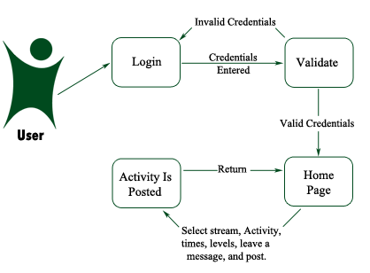

Scenario 2 –

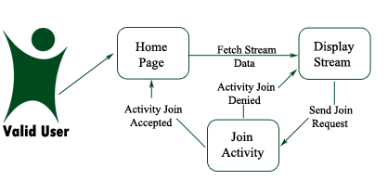

Scenario 3 –

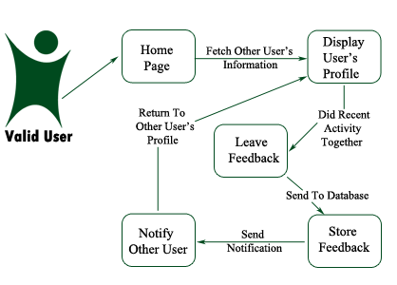

1. Functional Model

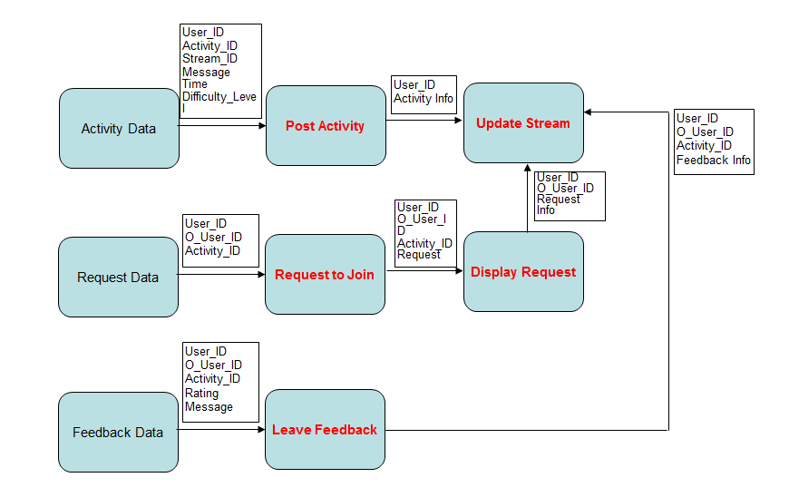

1. Revision History

|  |  |  |  |
| --- | --- | --- | --- |
| Person | Date Modified | Section | Description |
| Rob | 11/2 | 3.1, 3.2 | First draft |
| Ray | 11/2 | 1, 4 | First draft |
| Vince | 11/3 | / | Proofread and collated |
| Dave | 11/3 | 2.1, 2.2 | First draft |